**EXERCISE**

Q1. - Write a class with FirstName, LastName & age field. Print Firstname, LastName & age using static block, static method & static variable respectively.

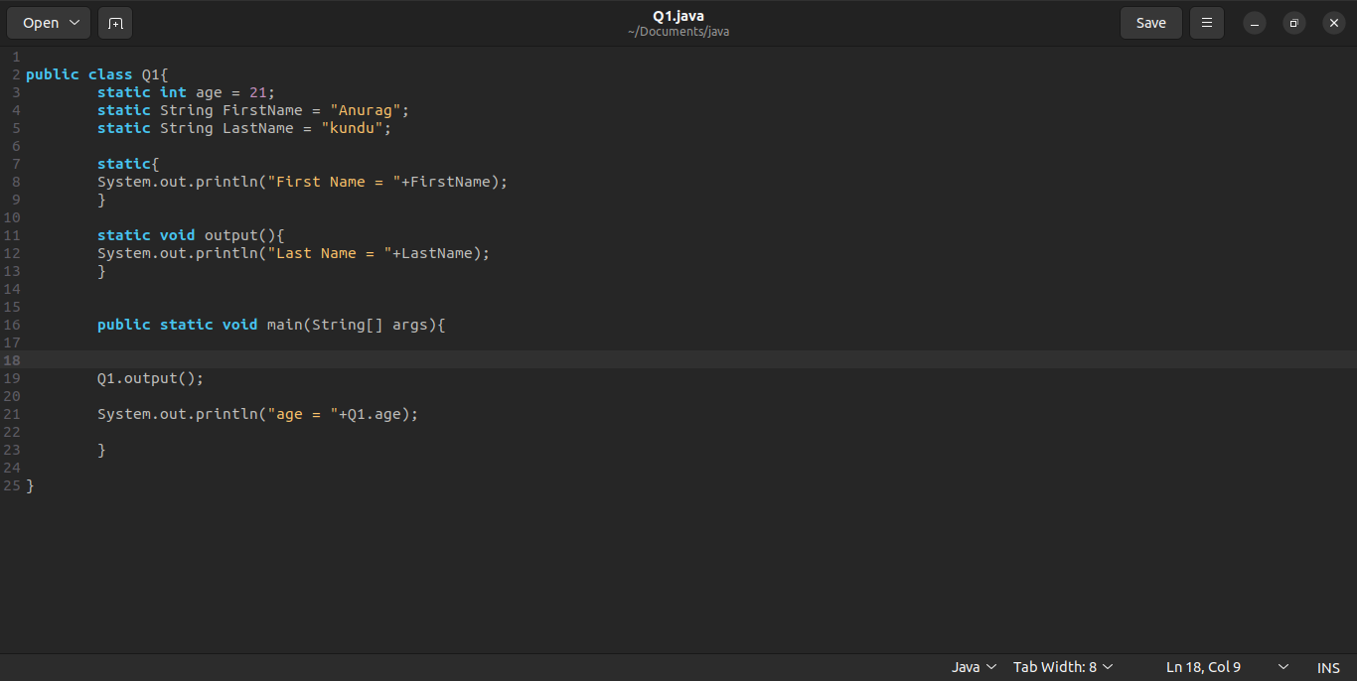

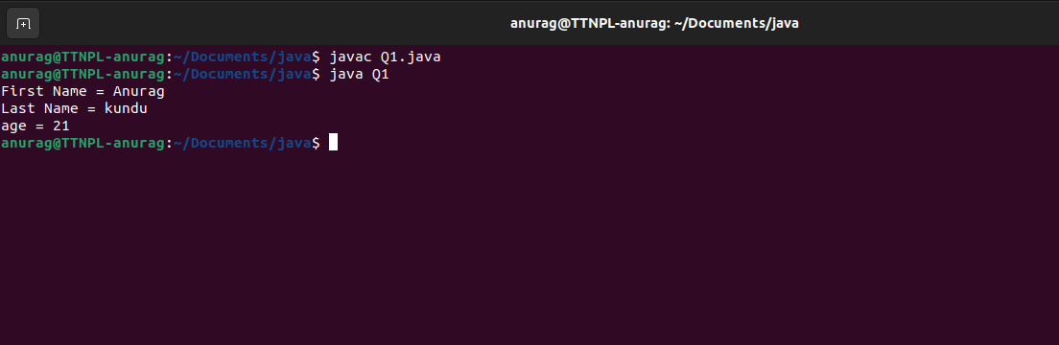

Q2. - Write a program to read user input until user writes XDONE and then show the entered text by the user on command line

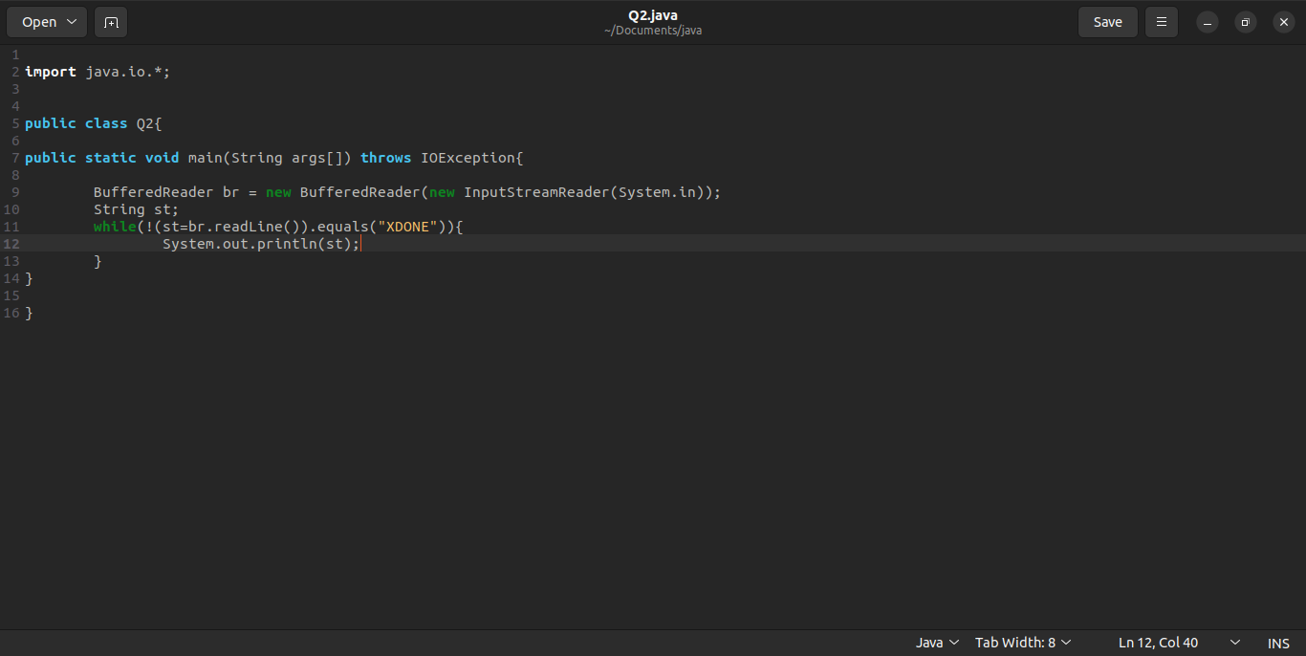

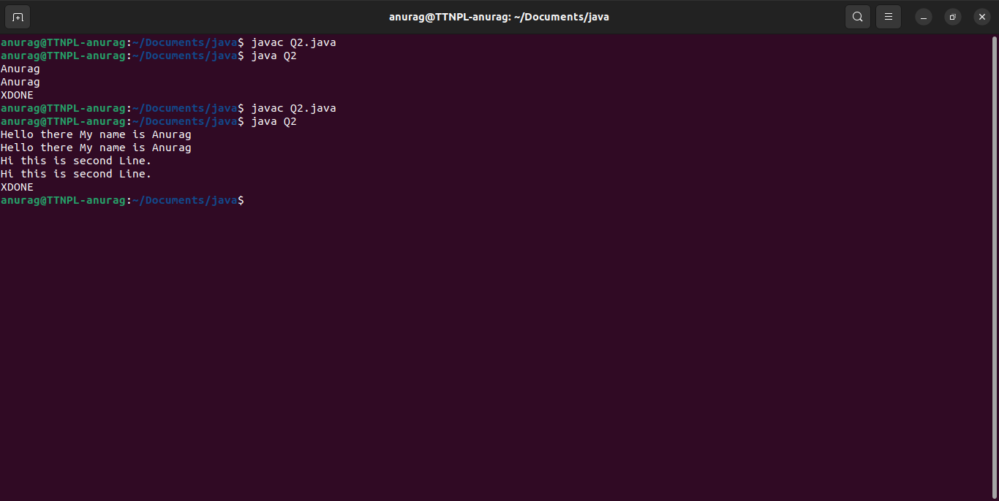

Q3. - Write a java program to show following menu to the user: *******Menu******* 1. Calculate Area of Circle 2. Calculate Circumference of a Circle 3. Exit. Choose an option (1-3): Take radius as user input.

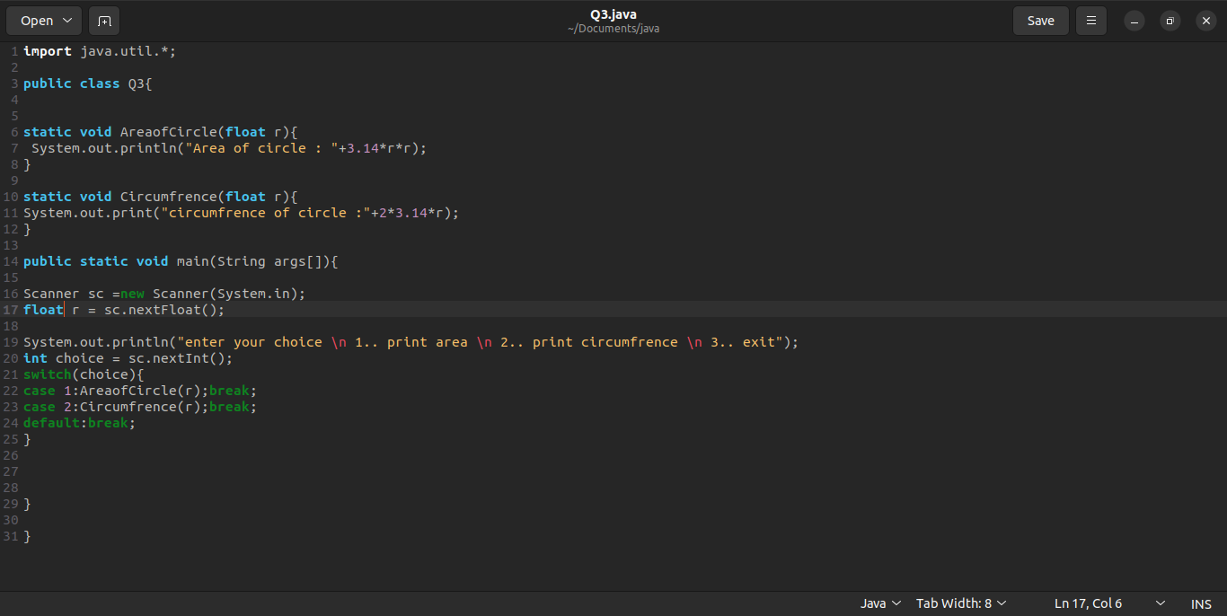

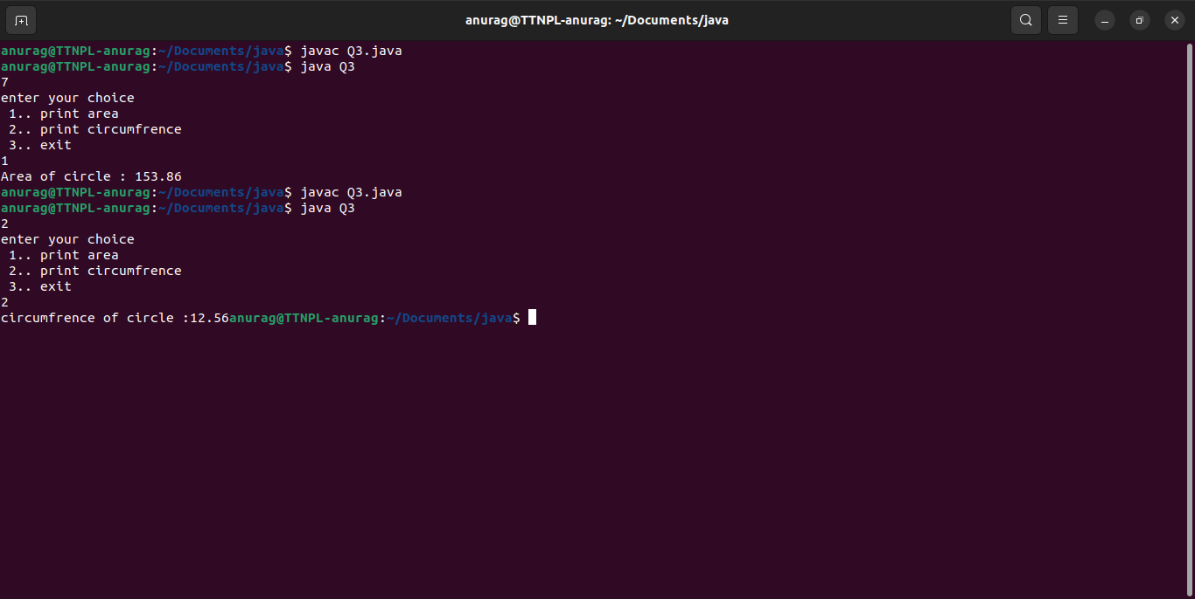

Q4. - Create a two dimensional array of integers and display: 1. sum of all elements of each column 2. sum of all elements of each row

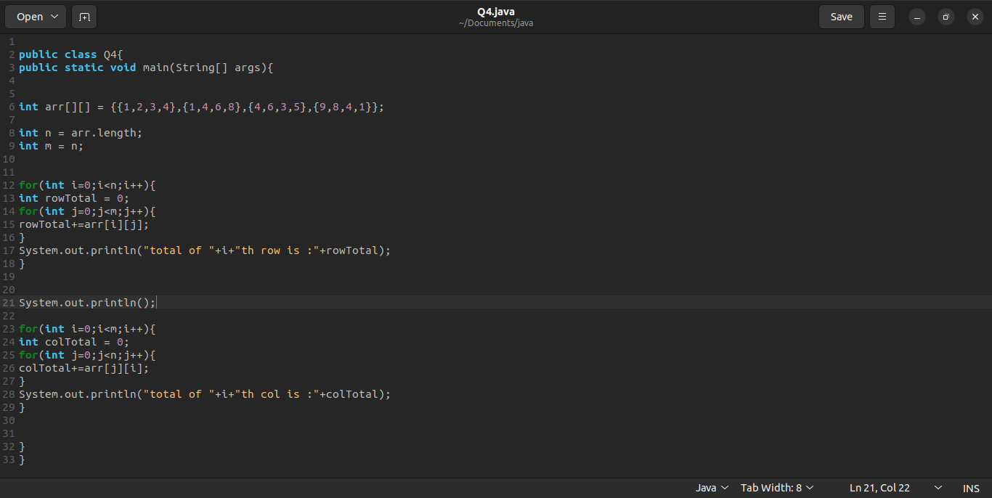

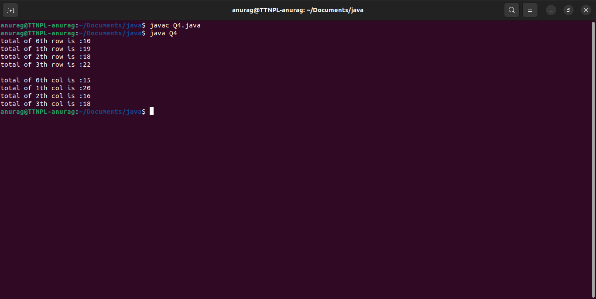

Q5. - Create a class named Employee with fields firstname,lastname,age and designation. The class should: 1. have all types of constructors to initialize the object 2. class should also have setter methods to update a particular field 3. Override its toString method to display a meaningful message using all these fields.

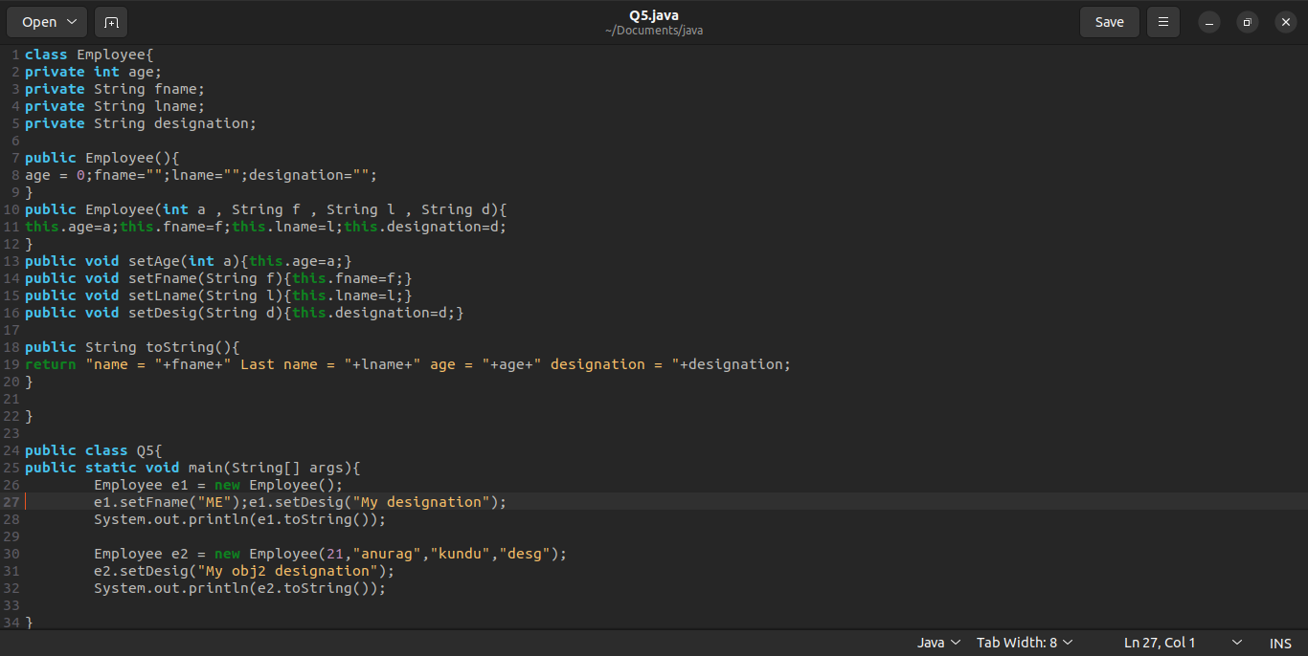

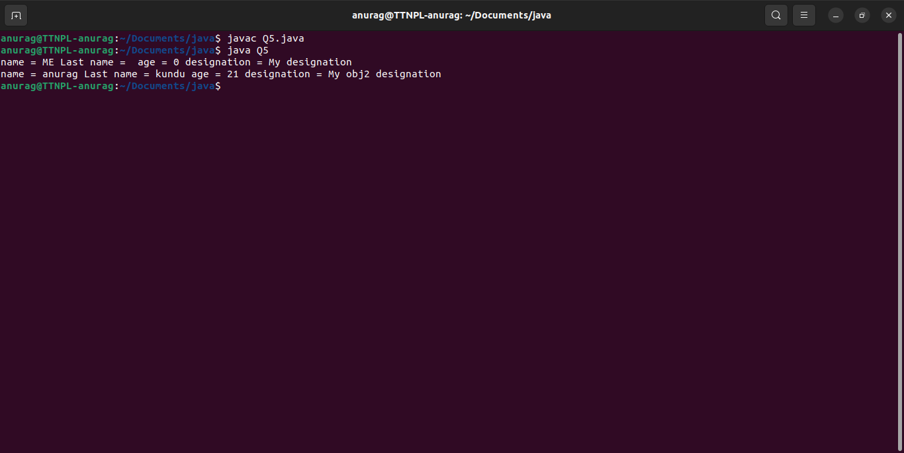

Q6. - Implement a banking system using java. Create 3 sub class of Bank : SBI, BOI, ICICI Classes should have attributes like Name, headofficeAddress, chairmanName, branchCount, fdInterestRate, personalLoanInterestRate, homeLoanInterestRate. All 3 should have following methods: 1. add getters and setters for the fields 2. print details of every bank (override toString)

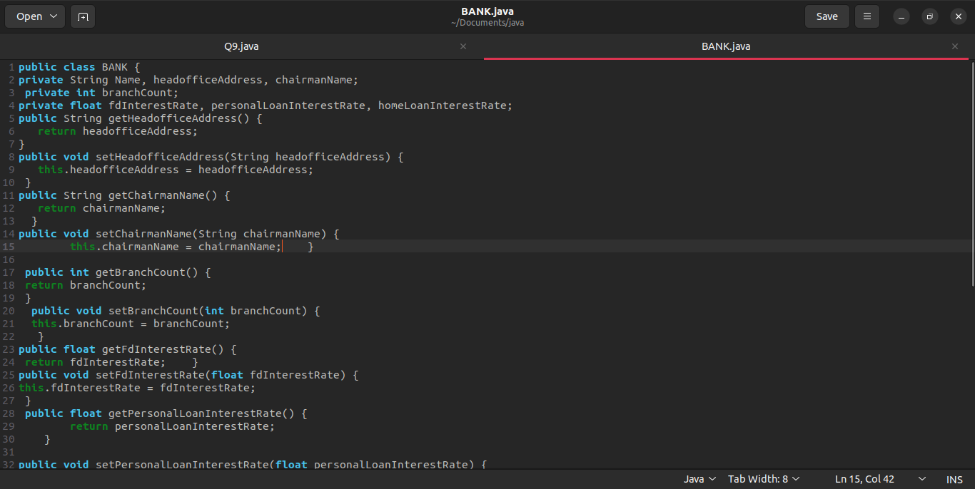

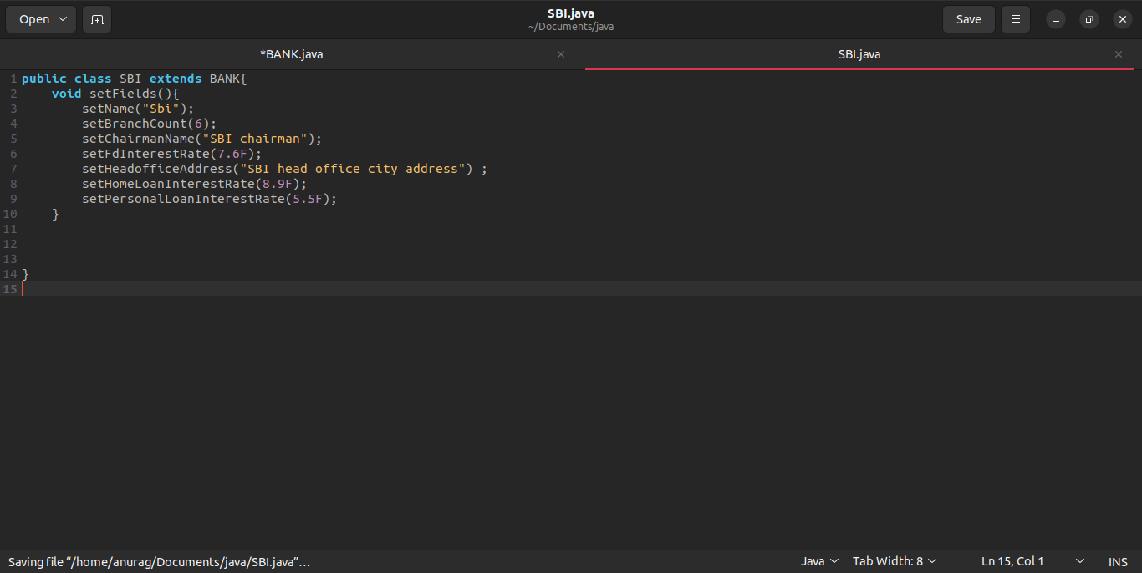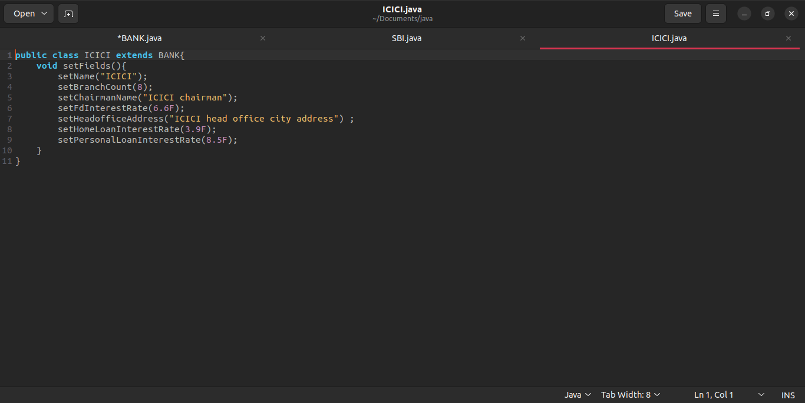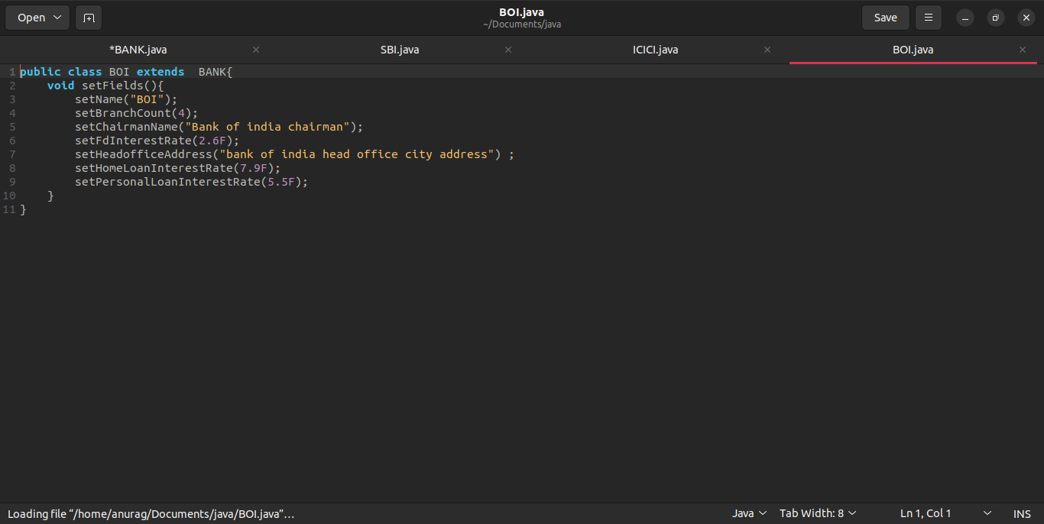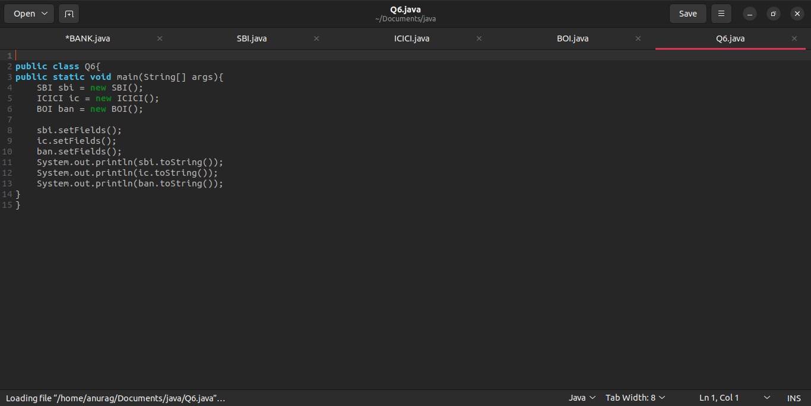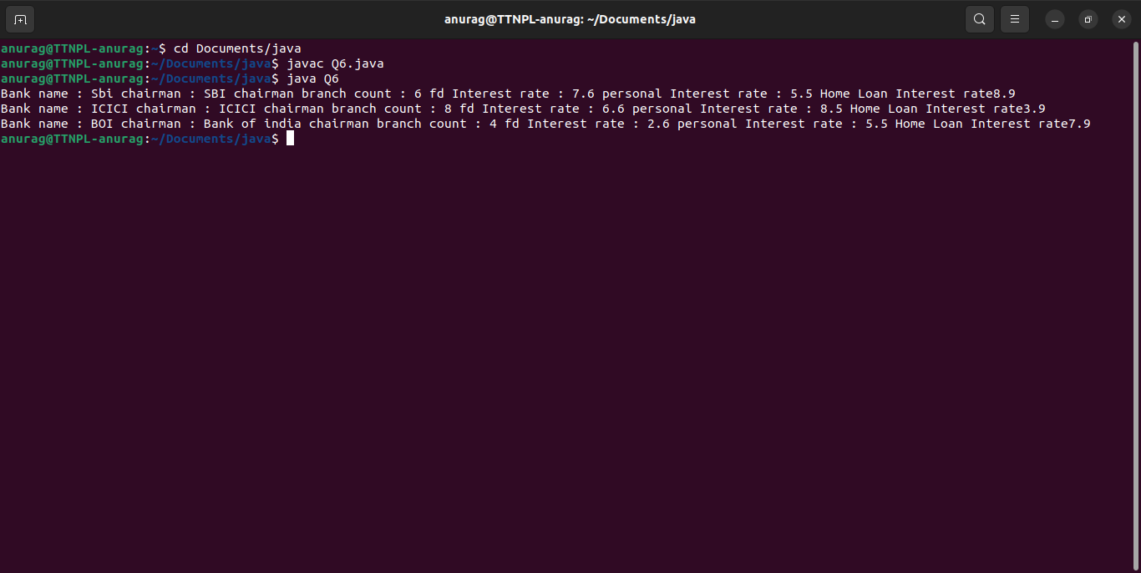

Q7. - WAP showing try, multi-catch and finally blocks.

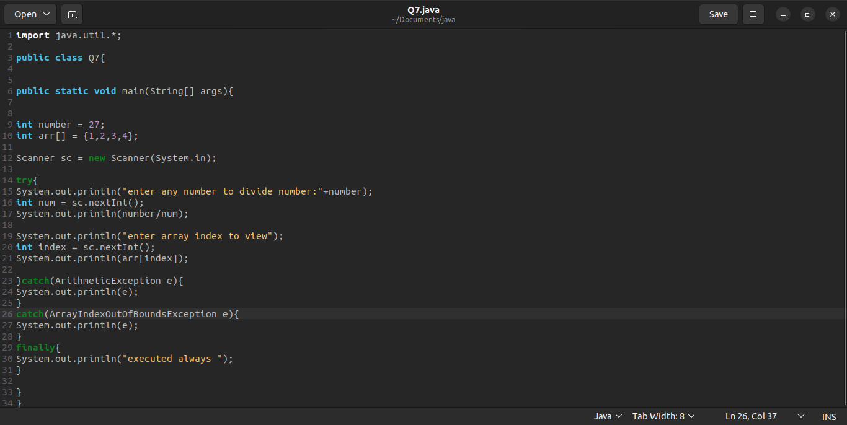

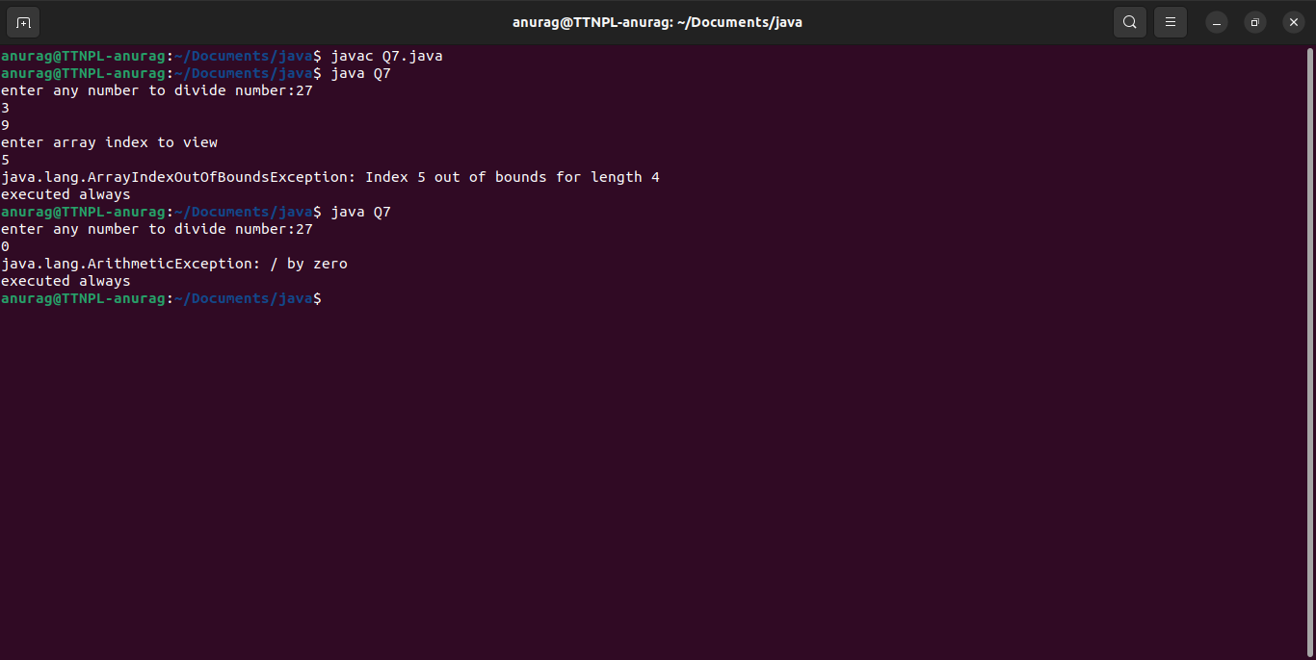

Q8. - WAP to produce NoClassDefFoundError and ClassNotFoundException exception.

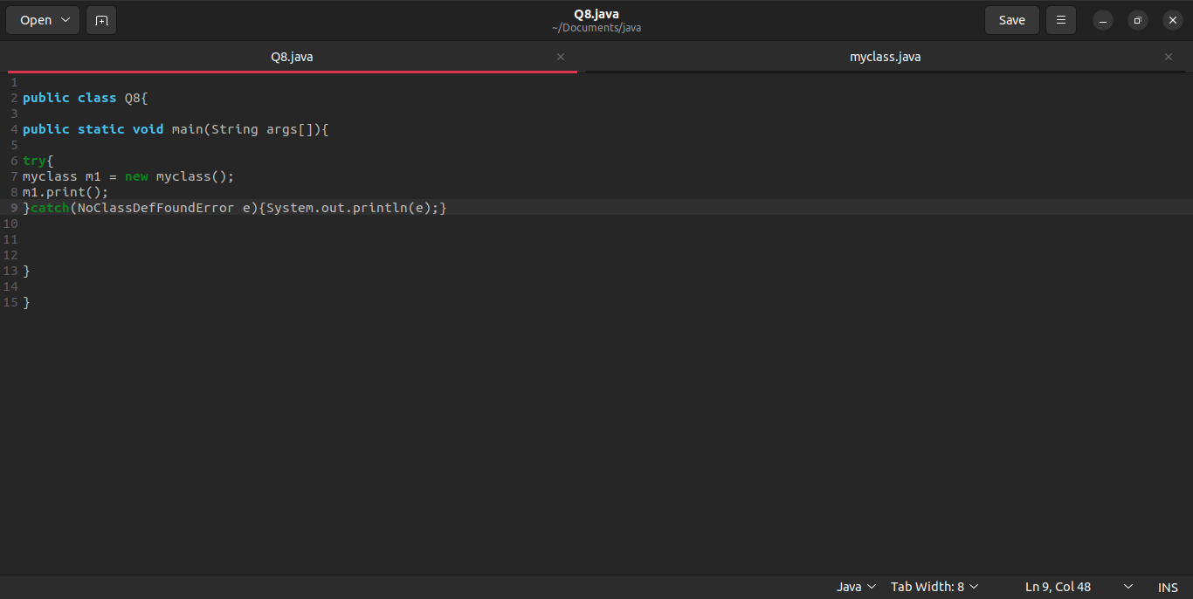

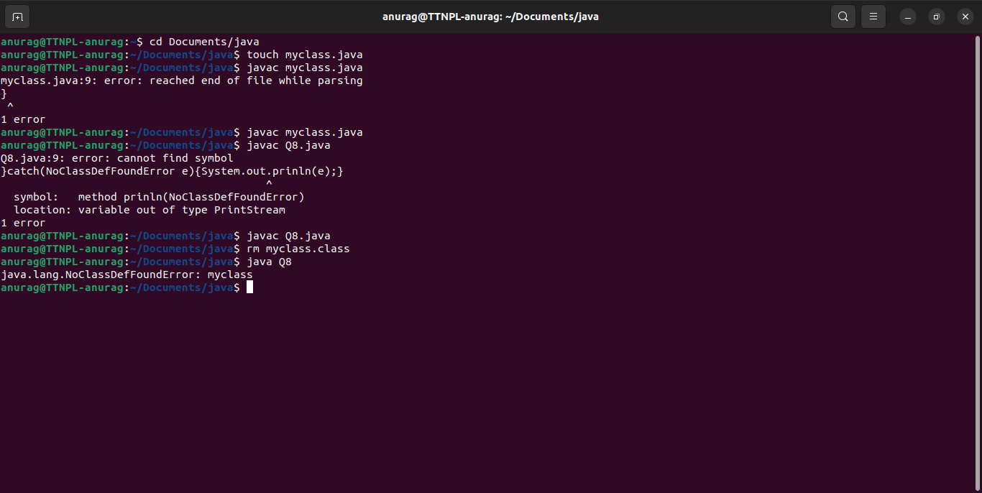

Q9. - Create a custom exception that do not have any stack trace.

